|  |  |
| --- | --- |
|  | **DEPARTMENT OF COMPUTER SYSTEMS ENGINEERING**  **MEHRAN UNIVERSITY OF ENGINEERING & TECHNOLOGY, JAMSHORO**  **Database Management Systems (4th Semester) 18CS**  **Lab Experiment 4** |

|  |  |  |  |
| --- | --- | --- | --- |
| **Roll No:** |  | **Date of Conduct:** |  |
| **Submission Date:** |  | **Grade Obtained:** |  |

|  |  |  |  |
| --- | --- | --- | --- |
| **Problem Recognition (0.3)** | **Completeness & accuracy (0.4)** | **Timeliness (0.3)** | **Score (1.0)** |
|  |  |  |  |

**Objective: To retrieve data from database using SQL SELECT Statement.**

**Tools: MySql / Oracle.**

**Introduction:**

**The SQL SELECT Statement**

* The SELECT statement is used to select data from a database.
* The data returned is stored in a result table, called the result-set.

**SELECT Syntax**

SELECT column1*,* column2 FROM table_name;

Here, column1, column2 are the field names of the table you want to select data from. If you want to select all the fields available in the table, use the following syntax:

SELECT * FROM table_name;

## SELECT Column Example

The following SQL statement selects the "CustomerName" and "City" columns from the "Customers" table:

### **Example**

SELECT CustomerName, City FROM Customers;

**Lab Task**

**1. Create a query to display unique departments from EMP table.**

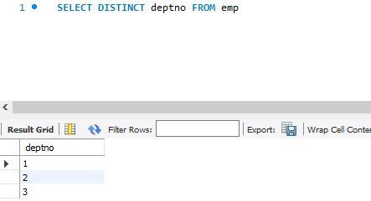**Solution:**

**2. Display the employee name, job, and joining date of employees hired between February 20, 1981 and May 1, 1981. Order the query in ascending order by joining date.**

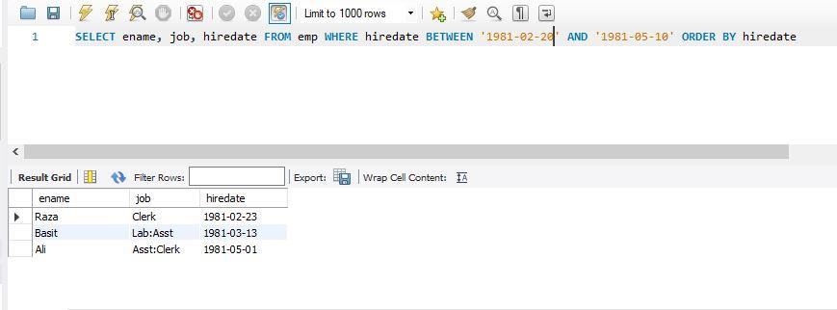**Solution:**

**3. Display the names of all employees who have two ‘L’ in their name and are in department 30 or their manager is 7782.**

**Solution:**

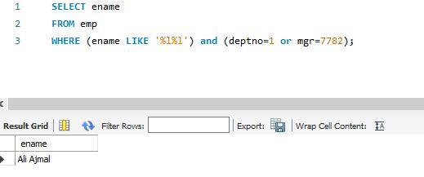

**4. Display the name, salary, and commission for all employees whose commission amount is greater than their salary increased by 10%.**

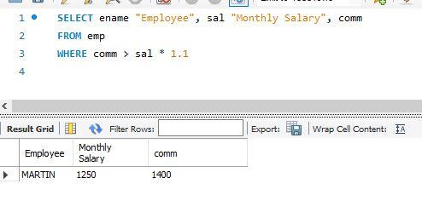**Solution:**

**5. Display the name and salary of employees who earn more than 1500 and are in department 10 or 30. Label the columns Employee and Monthly Salary, respectively.**

**Solution:**

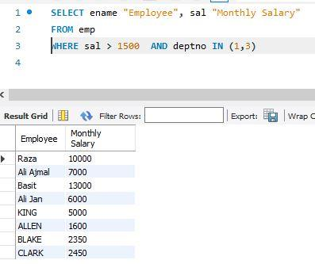

**6. List out the employees whose name start with S and ends with H.**

**Solution:**

**7. Write a query that produces following for each employee: earns monthly but wants. Label the column Dream Salaries.**

**Solution:**

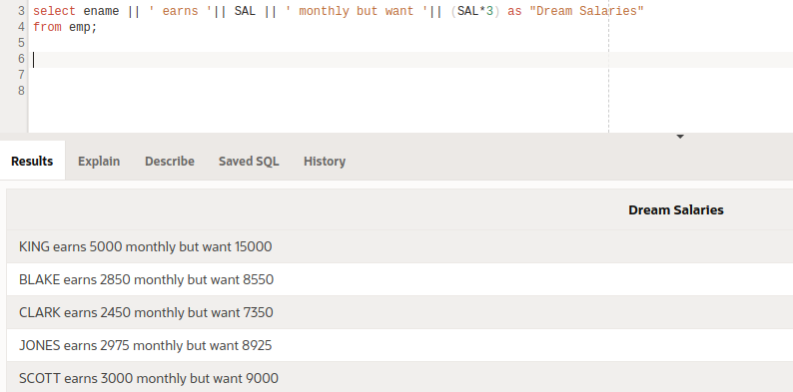

**8. Display the name job and salary for all employees whose job is clerk or analyst and their salary is not equal to 1000, 3000, or 5000.**

**Solution:**

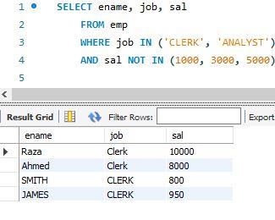

**9. Display the names of all employees where the third letter of their name is an A.**

**Solution:**

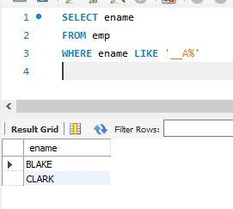

**10. Display name, salary and commission for all employees who earn commission. Sort the result in descending order of salary and commission.**

**Solution:**

